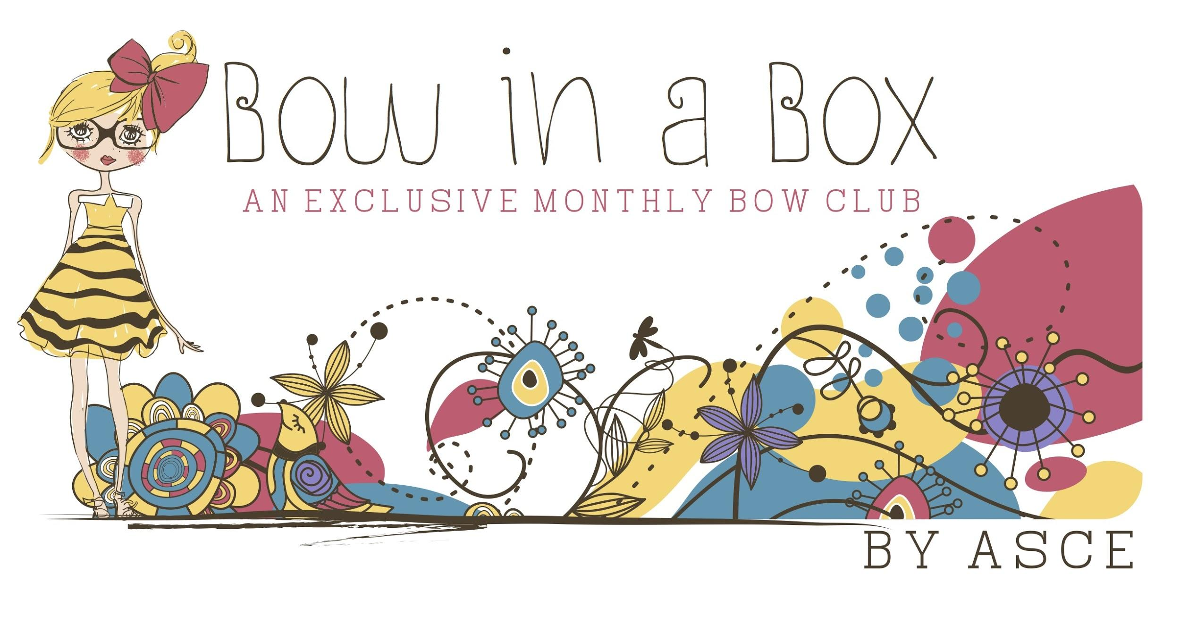
TERMS + CONDITIONS
INFORMATION YOU NEED TO KNOW

By using, accessing, or purchasing from this website ("Site"), which is owned and operated by Bow in a Box, you acknowledge that you have read, understood, and agree to the following Terms of Service ("Terms" or "Agreement"). If, at any time, you do not agree to these Terms, please do not use this Site. Bow in a Box reserves the right to revise these Terms at any time by updating this posting. Please read and review these Terms periodically. As a condition of your use of this Site, you agree that you are at least 18 years of age or are visiting the Site under the supervision of an adult or guardian and that you possess the authority to enter into a binding legal agreement. We grant you a personal, limited, non-transferable non-exclusive, license to access and use the Site via a browser. We reserve the right to revise the products and services available on the Site and to impose rules for and limits on use of the Site or to restrict your access to part, or all, of the Site without notice. We reserve the right to revoke your access at any time for any reason, including as a result of a violation of these Terms, without notice.

Bow in a Box reserves the right to change these terms & conditions of use at any time without notice.

By accessing or using any part of the site, you accept these terms, without limitation or qualification. You may not use any portion of the site if you do not agree with all of the terms set forth below. Price information found on this site is subject to change without notice.

We grant you a personal, limited, non-transferable non-exclusive, license to access and use the Site. We reserve the right, in our sole discretion and without notice to you, to revise the products and services available on the Site and to change, suspend or discontinue any aspect of the Site and we will not be liable to you or to any third party for doing so. We may also impose rules for and limits on use of the Site or restrict your access to part, or all, of the Site without notice or penalty. Your continued use of the Site will constitute your acceptance of any such changes.

Use of the Website
We give you permission to access and use the Site for your personal use, and to copy, distribute, and transmit the content of this Site only to the extent that such copying, distribution, and transmission is automatically done through your browser software incidentally to using the Site for your personal use. No mechanized or other systematic process for harvesting information from this Site for any purpose, including without limitation, any commercial purpose, is permitted. Any other use, including but not limited to the reproduction, distribution, display or transmission of the content of this Site is strictly prohibited, unless authorized in writing. You further agree not to change or delete any proprietary notices from materials downloaded from this Site. You may print a copy of the information displayed on this Site for your personal use. That means, that except as set forth above, you may not modify, reformat, copy, display, distribute, transmit, publish, license, create derivative works from, transfer or sell any information obtained by your use of this Site. This restriction means, among other things, that you may not mirror on your own website any portion of this Site or display through your own website any results pages or other information from this Site without express written permission. For the avoidance of doubt, you acknowledge and agree that your access to and use of the Site does not give you any right to use the name, likeness, image, signature, biographical information or any other rights of publicity or intellectual property of our celebrity spokespersons found on the Site.

We reserve the right to change any information, features and functions of the Site without prior notice. We may deny you access to all or part of the Site without prior notice if you engage in any conduct or activities that we determine, in our sole discretion, violate this Agreement, our rights or the rights of any third party.

We may assign you a password and account identification to enable you to access and use certain portions of this Site. Each time you use a password or identification, you will be deemed to be authorized to access and use the Site in a manner consistent with these Terms and Bow in a Box has no obligation to investigate the authorization or source of any such access or use of the Site.

You will be solely responsible for all access to and use of this site by anyone using the password and identification originally assigned to your whether or not such access to and use of the this site is actually authorized by you, including without limitation, all communications and transmissions and all obligations (including without limitation financial obligations) incurred through such access or use.

You are solely responsible for protecting the security and confidentiality of the password and identification assigned to you. You shall immediately notify Bow in a Box of any unauthorized use of your password or identification or any other breach or threatened breach of this Site's security.

You may receive emails regarding your account or promotions for special offers, including third party offers.

Billing and Payments
As a Member, you agree to the following benefits and Terms:

You must provide us and keep us up to date with accurate contact and payment information, including name, shipping address, and credit or debit card number. We save your payment information for ease of future shipments and charges. All such personal information is subject to the Privacy Policy. You are responsible for any fees or charges your issuing bank or credit card provider may charge you. If your payment to us is returned for any reason, we may bill your account again directly and seek payment by another method including a mailed statement. Any account changes made after the 5th of each month should not be expected to reflect on the subscription until the following shipping period.

Your Subscription Contract
By purchasing any subscription, you acknowledge that your subscription has an initial and recurring payment feature and you accept responsibility for all recurring charges prior to cancellation. Your subscription will be automatically extended for successive periods, at the then-current subscription rate. To cancel your subscription at any time, you must email support at least 48 hours prior to your next scheduled renewal date to avoid charge. All subscriptions that are started between the 6th and the 19th of any given month will automatically have their renewal date moved to the 5th of the following subscription period. If you cancel, you may use your subscription until the end of your then-current subscription term. Loot Crate may submit periodic charges (e.g., monthly) without further authorization from you, until you provide prior notice that you have terminated this authorization or wish to change your payment method within the 48-hour notice requirement.

If you cancel your subscription, you will not be eligible for a prorated refund of any portion of the subscription fee paid for the then-current subscription period. We reserve the right to revoke your subscription at any time. Returns with the request of a refund will be refunded the paid for subscription cost minus the shipping and is at the discretion of customer support. Membership is void where prohibited by law.

Product Information; Limitation on Quantities
Excluding any content which may be submitted by Members from time to time, we strive to ensure that the information on the Site is complete and reliable. Certain information may contain pricing errors, typographical errors and other errors or inaccuracies which we may correct without liability. We also reserve the right to limit quantities purchased by Members and to revise, suspend, or terminate an event or promotion at any time without notice (including after an order has been submitted and/or acknowledged). We do not guarantee that all products described on our Site will be available.

Risk of Loss
Any merchandise purchased from our Site will be shipped by a third party carrier. As a result, title and risk of loss or damage for such merchandise will pass to you upon our delivery to the carrier. All missing or damaged shipments or items must be reported within 30 days of shipping to qualify for a replacement or refund based on product availability. If the product is available, a replacement will be shipped and a refund will not be issued or considered. Damaged items must be reported and include a photo in the ticket submission. Damaged items will be reviewed by the support agent and a replacement will be issued only for damaged products and does not cover or include packaging of said item. Blemishes to packaging will not be considered as part of a damaged item. All refunds will be at the discretion of customer support.

Copyright
The technology underlying, and the entire content included in, the Site, including but not limited to text, graphics or code is copyrighted as a collective work under the United States and other copyright laws, and is the property of Bow in A Box and is protected by copyright and other intellectual property or proprietary rights. The collective work includes works that are licensed to Bow in a Box. Copyright 2014 Bow in a Box. All rights reserved. We do not investigate to determine if such works are accurate nor can we provide assurance that all such works are free of typographical errors. We cannot guarantee information displayed on this Site to be 100% accurate.

Trademarks
All trademarks, service marks, and trade names of Bow in a Box on the Site are trademarks or registered trademarks of Bow in a Box, or of their respective owners.

User Generated Content
By sharing, submitting and uploading any of your data including but not limited to photographs, images, video, music, art, or comments, you grant Bow in a Box a worldwide, non-exclusive, royalty-free, sub-licensable and transferable license to use, reproduce, prepare derivative works of, display and perform your user data in any legal manner for the benefit of Loot Crate. You acknowledge and agree that you are solely responsible for all the user data that you make available through Bow in a Box. Accordingly, you represent and warrant that: (1) you have all rights, licenses, consents and releases necessary to grant Bow in a Box the required rights to disseminate any user data, (2) neither your data nor your posting, uploading, publication, submission or transmittal of this data or Bow in a Box use of your uploaded data (or any portion thereof) on, through or by the means of Bow in a Box will infringe, misappropriate or violate a third partys’ patent, copyright, trademark, trade secret, moral rights or other intellectual property rights or rights of publicity or privacy or result in the violation of any applicable law or regulation.

Warranty Disclaimer
Except as otherwise specifically provided, the site and the products offered on the site are provided on as “as is” and “as available” basis without warranties or any kind, whether express or implied. To the fullest extent permissible pursuant to applicable law, Loot Crate disclaims all warranties, express or implied, including, but not limited to, implied warranties of merchantability and fitness for a particular purpose and non-infringement. Bow in a Box does not represent or warrant that the functions contained on the site will be uninterrupted or error-free, that the defects will be corrected, or that the site or the server that makes the site available are free or viruses or other harmful components. Loot crate does not make any warrantees or representations regarding the use of the materials on the site in terms of their correctness, accuracy, adequacy, usefulness, timeliness, reliability or otherwise. Applicable Law may not allow limitations or exclusions on warranties, so the above limitations may not apply to you.

Limitation of Liability
Neither Bow in a Box nor its spokespersons shall be liable for any indirect, incidental, special or consequential damages that result from the use of, or the inability to use, the site or materials on or provided through the site, even if Bow in a Box has been advised of the possibility of such damages. In no event will Bow in a Box liability to you exceed the amounts that you paid to Bow in a BOx in connection with your Bow in a Box membership. Applicable law may not allow the limitation of exclusion of liability or incidental or consequential damages, so the above limitation or exclusion may not apply to you.

In the event a product is listed at an incorrect price or with incorrect information due to typographical error or error in pricing or product information received from our suppliers,Bow in a Box shall have the right to refuse or cancel any orders placed for product listed at the incorrect price. Bow in a Box shall have the right to refuse or cancel any such orders whether or not the order has been confirmed and your credit card charged. If your credit card has already been charged for the purchase and your order is canceled, Bow in a Box shall immediately issue a credit to your credit card account in the amount of the charge.

Loot Crate has no liability on injury or damage caused by products within the crate. Solely responsible by brand or manufacturer.

Taxes
Your total price will include the price of the product plus any applicable sales tax; such state and local sales tax is based on the shipping address and the sales tax rate in effect at the time you purchase the product. We will charge tax only in states where the goods sold over the internet is taxable.

International Use
We control and operate the Site from the United States. We make no representation that materials on the Site are appropriate or available for use outside the United States. If you choose to access this Site from outside the United States, you do so at your own initiative and are responsible for compliance with local laws, if and to the extent local laws are applicable. All pricing is in United State dollars. Any subscriptions under an incorrect plan will be canceled and any applicable charges refunded without notice to the subscriber.

Limitation of Liability
These Terms are applicable to you upon your accessing the Site. These Terms, or any part of them, may be modified or terminated by Bow in a Box without notice at any time, for any reason. The provisions relating to Copyrights, Trademark, Disclaimer, Limitation of Liability, Indemnification, and Miscellaneous, shall in all events survive any termination of these Terms and your use of the Site.

Notice
Bow in a Box may deliver notice to you by means of e-mail, a general notice on this Site, or by other reliable method.

Use of Site
Use of the Site for any illegal or unauthorized purpose is strictly prohibited.

Indemnification
You agree to indemnify, defend, and hold harmless Bow in a Box , its officers, directors, employees, agents, licensors and suppliers from and against all losses, liabilities, expenses, damages, and costs, including reasonable attorneys' fees, resulting from any violation of these Terms, or any activity related to use of the Site (including negligent or wrongful conduct) by you or any other person accessing the Site using your Internet account.

Privacy
Registration data and certain other information about you are subject to our Privacy Policy.

You understand that the technical processing and transmission of this Site may involve (a) transmissions over various networks; and (b) changes to conform and adapt to technical requirements of connecting networks or devices.

Third-Party Links: In an attempt to provide increased value to our visitors, Bow in a Box may link to sites operated by third parties. However, Bow in a Box has no control over these linked sites, all of which have separate privacy and data collection practices, independent of Bow in a Box. These linked sites are only for your convenience and therefore you access them at your own risk. Nonetheless, Bow is a Box seeks to protect the integrity of its Site and the links placed upon it and therefore requests any feedback on not only its own Site, but for sites it links to as well (including if a specific link does not work).

Miscellaneous: Your use of the Site is governed in all respects by the laws of the state of Oklahoma, USA, without regard to choice of law provisions, except to the extent that federal law applies. These Terms evidences a transaction involving interstate commerce, and the United States Arbitration Act shall apply in all cases and govern the interpretation and enforcement of the arbitration rules and arbitration proceedings. Any claims arising out of, relating to, or connected with these Terms or your use of the Site and Bow in a Box must be asserted individually in binding arbitration administered by the American Arbitration Association (AAA) in accordance with its Commercial Arbitration Rules and the AAA Supplementary Procedures for Consumer-Related Disputes. The arbitrator shall not conduct any form of class or collective arbitration nor join or consolidate claims by or for individuals. The Arbitrator, and not any federal, state, or local court or agency, shall have exclusive authority to resolve any dispute relating to the interpretation, applicability, enforceability or formation of these Terms including, but not limited to, any claim that all or any part of these Terms is void or voidable. Judgment on the award rendered by the arbitrator may be entered in any court of competent jurisdiction. There are only two exceptions to this arbitration agreement. First, if we reasonably believe that you have in any manner violated or threatened to violate our intellectual property rights, you agree that we would be irreparably harmed by such violation or use and that we may seek injunctive or other appropriate relief in any court of competent jurisdiction. Second, any claim of $500 or less may, at the option of the claiming party, be resolved in small claims court in Tulsa, Ok, if the claim and the parties are within the jurisdiction of the small claims court. By agreeing to these Terms, you hereby irrevocably waive any right you may have to a court trial (other than small claims court) or to serve as a representative, as a private attorney general, or in any other representative capacity, or to participate as a member of a class of claimants, in any lawsuit, arbitration or other proceeding filed against us and/or related third parties. You acknowledge that this means that you may not have access to a court or jury.

Any cause of action or claim you may have with respect to the Site must be commenced within one (1) year after the claim or cause of action arises or is barred forever. Failure to insist upon or enforce strict performance of any provision of these Terms shall not be construed as a waiver of any provision or right.

These Terms constitute the entire agreement between you and Bow in a Box with regard to your use of the Site. Neither the course of conduct between the parties nor trade practice shall act to modify any of these Terms. Bow in a Box may assign its rights and duties under this Agreement to any party at any time without notice to you.

